EXP-2
clc;
clear;
close all;
Am=1;
fm=500;
Ac=5;
fc=5000;
fs=20*fc;
t=0:1/fs:4/fm;
m = Am*sin(2*pi*fm*t);
c = Ac*sin(2*pi*fc*t);
mu = Am/Ac;
am = Ac*(1+mu*sin(2*pi*fm*t)).*sin(2*pi*fc*t);
dem = abs(hilbert(am)); dem = dem-mean(dem);
N=length(am); f=linspace(-fs/2,fs/2,N);
AM_FFT=abs(fftshift(fft(am)))/N;
USB=fc+fm; LSB=fc-fm;
Pc=Ac^2/2; Psb=(mu^2*Pc)/4;
figure('Name','AM Modulation','NumberTitle','off');
subplot(3,2,1), plot(t,m), title('Message'), grid on
subplot(3,2,2), plot(t,c), title('Carrier'), grid on
subplot(3,2,3), plot(t,am), title('AM Signal'), grid on
subplot(3,2,4), plot(t,dem), title('Demodulated'), grid on
subplot(3,2,5), plot(f,AM_FFT), xlim([fc-3*fm fc+3*fm]), title('Sidebands'), grid on
subplot(3,2,6), bar([Pc Psb Psb]), set(gca,'XTickLabel',{'Carrier','USB','LSB'}),
title('Power'), grid on
fprintf('μ=%.2f | USB=%d Hz | LSB=%d Hz | Pc=%.2f W | Psb=%.3f
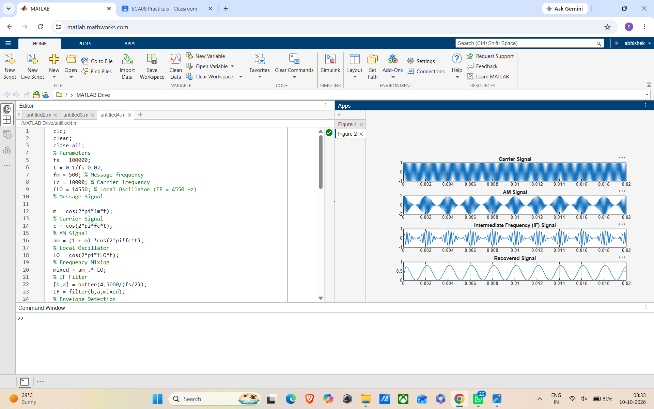

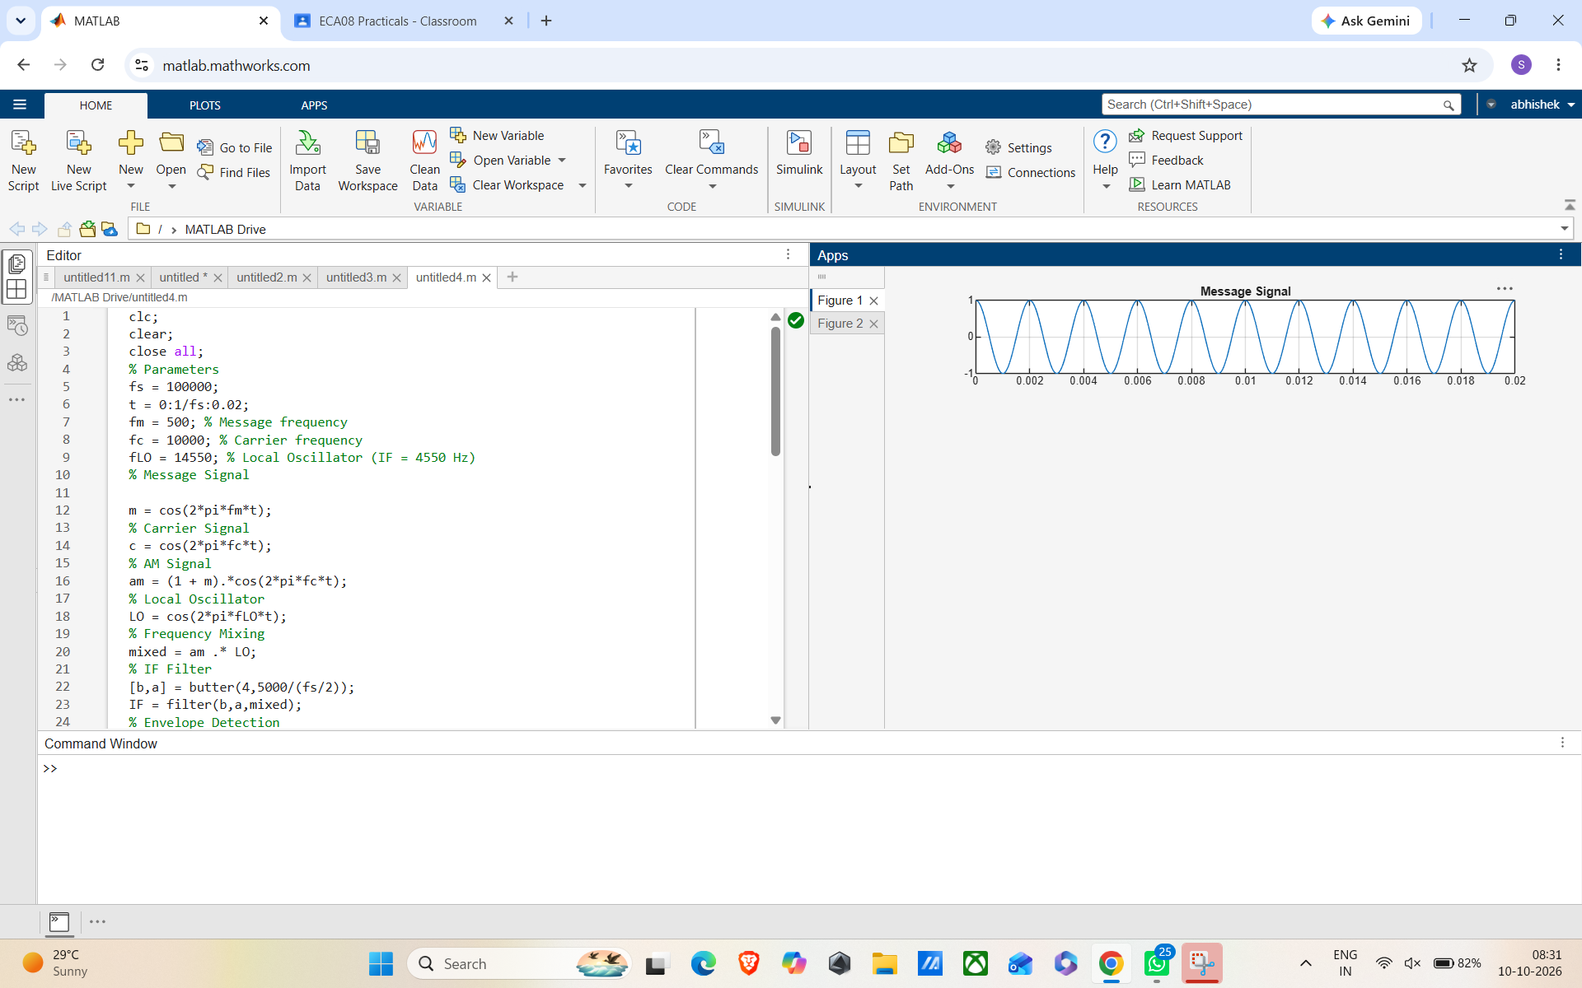

EXP-3
clc;

clear;
close all;
% Parameters
fs = 100000; % Sampling Frequency
t = 0:1/fs:0.02; % Time Vector
fm = 500; % Message Frequency
fc = 5000; % Carrier Frequency
% Message Signal
m = cos(2*pi*fm*t);
% Carrier Signal
c = cos(2*pi*fc*t);
% DSB-SC Modulation
dsb = m .* c;
% VSB Filter (Low-pass + High-pass Approximation)
[b,a] = butter(4, fc/(fs/2));
vsb = filter(b,a,dsb);
% Coherent Demodulation
demod = vsb .* (2*cos(2*pi*fc*t));
% Recover Message
[b1,a1] = butter(4, 1000/(fs/2));
rec = filter(b1,a1,demod);
% Display Results
figure;
subplot(5,1,1)
plot(t,m)
title('Message Signal')
grid on
subplot(5,1,2)
plot(t,c)
title('Carrier Signal')
grid on
subplot(5,1,3)
plot(t,dsb)
title('DSB-SC Signal')
grid on
subplot(5,1,4)
plot(t,vsb)
title('VSB Signal')
grid on
subplot(5,1,5)
plot(t,rec,'r')
title('Recovered Message')
grid on

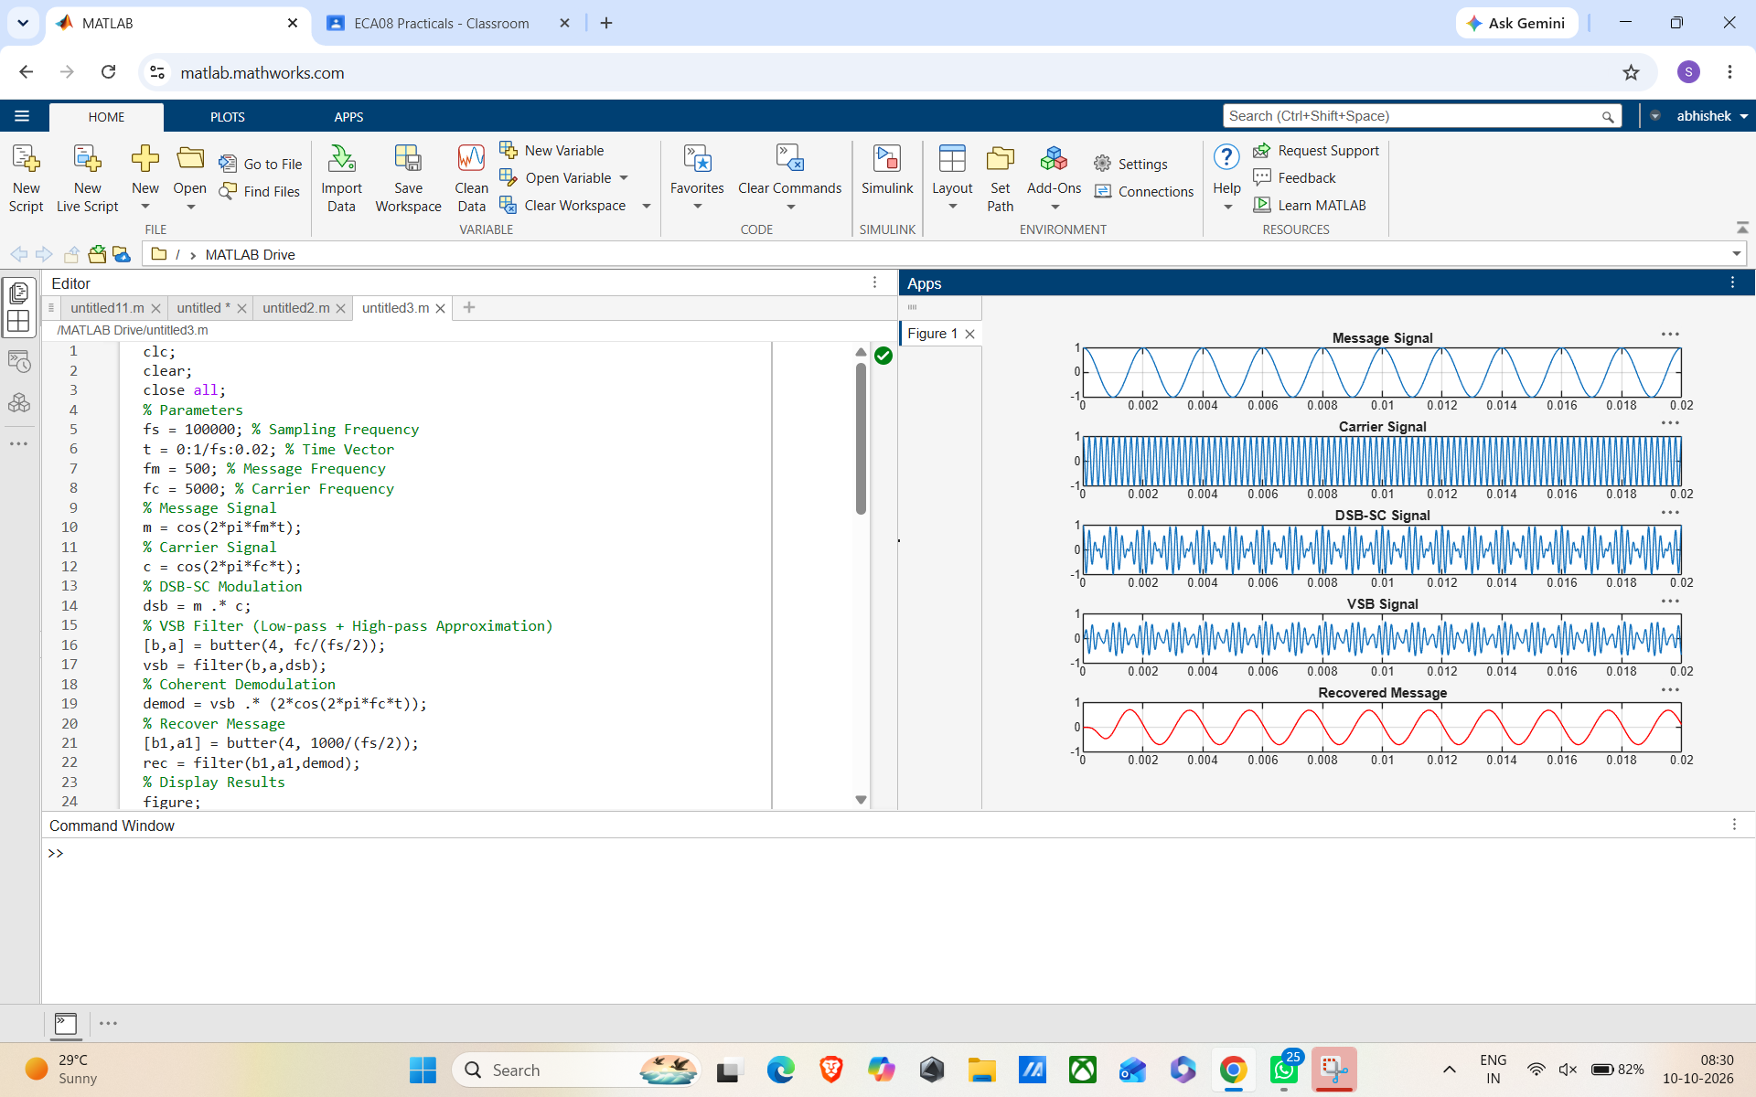

EXP-4
clc;
clear;
close all;
% Parameters
fs = 100000;
t = 0:1/fs:0.02;
fm = 500; % Message frequency
fc = 10000; % Carrier frequency
fLO = 14550; % Local Oscillator (IF = 4550 Hz)
% Message Signal

m = cos(2*pi*fm*t);
% Carrier Signal
c = cos(2*pi*fc*t);
% AM Signal
am = (1 + m).*cos(2*pi*fc*t);
% Local Oscillator
LO = cos(2*pi*fLO*t);
% Frequency Mixing
mixed = am .* LO;
% IF Filter
[b,a] = butter(4,5000/(fs/2));
IF = filter(b,a,mixed);
% Envelope Detection
env = abs(hilbert(IF));
% Display
figure;
subplot(4,1,1)
plot(t,m)
title('Message Signal')
grid on
figure;
subplot(5,1,2)
plot(t,c)
title('Carrier Signal')
grid on
subplot(5,1,3)
plot(t,am)
title('AM Signal')
grid on
subplot(5,1,4)
plot(t,IF)
title('Intermediate Frequency (IF) Signal')
grid on
subplot(5,1,5)
plot(t,env)
title('Recovered Signal')
grid on

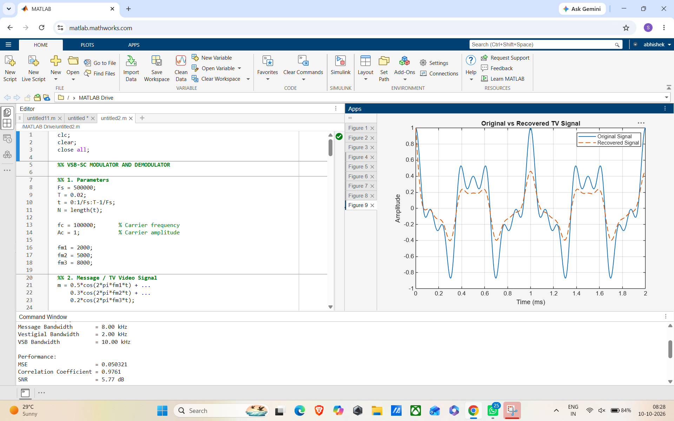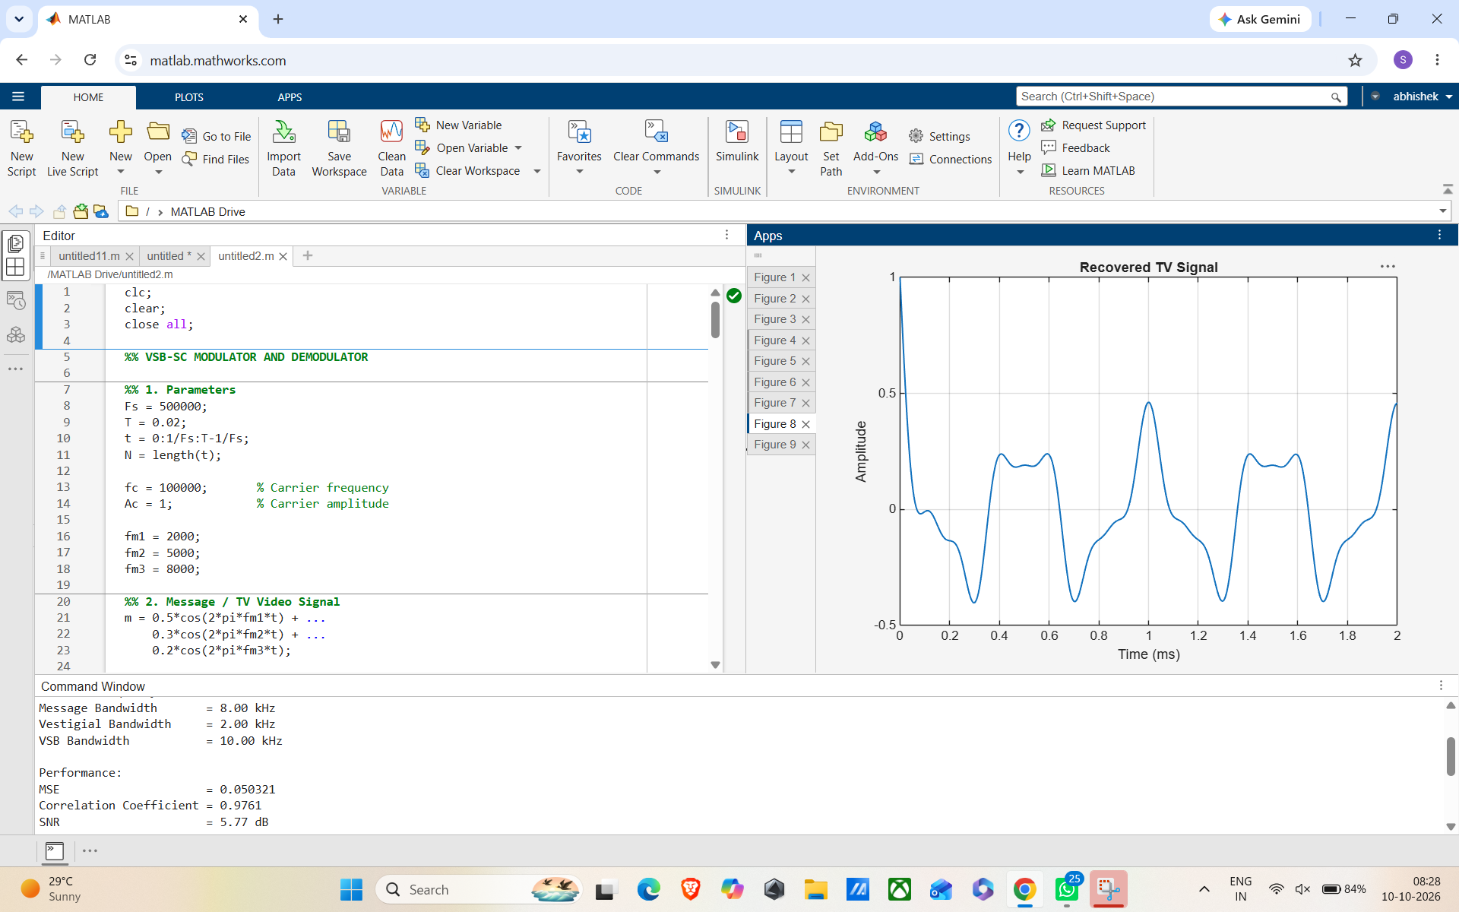
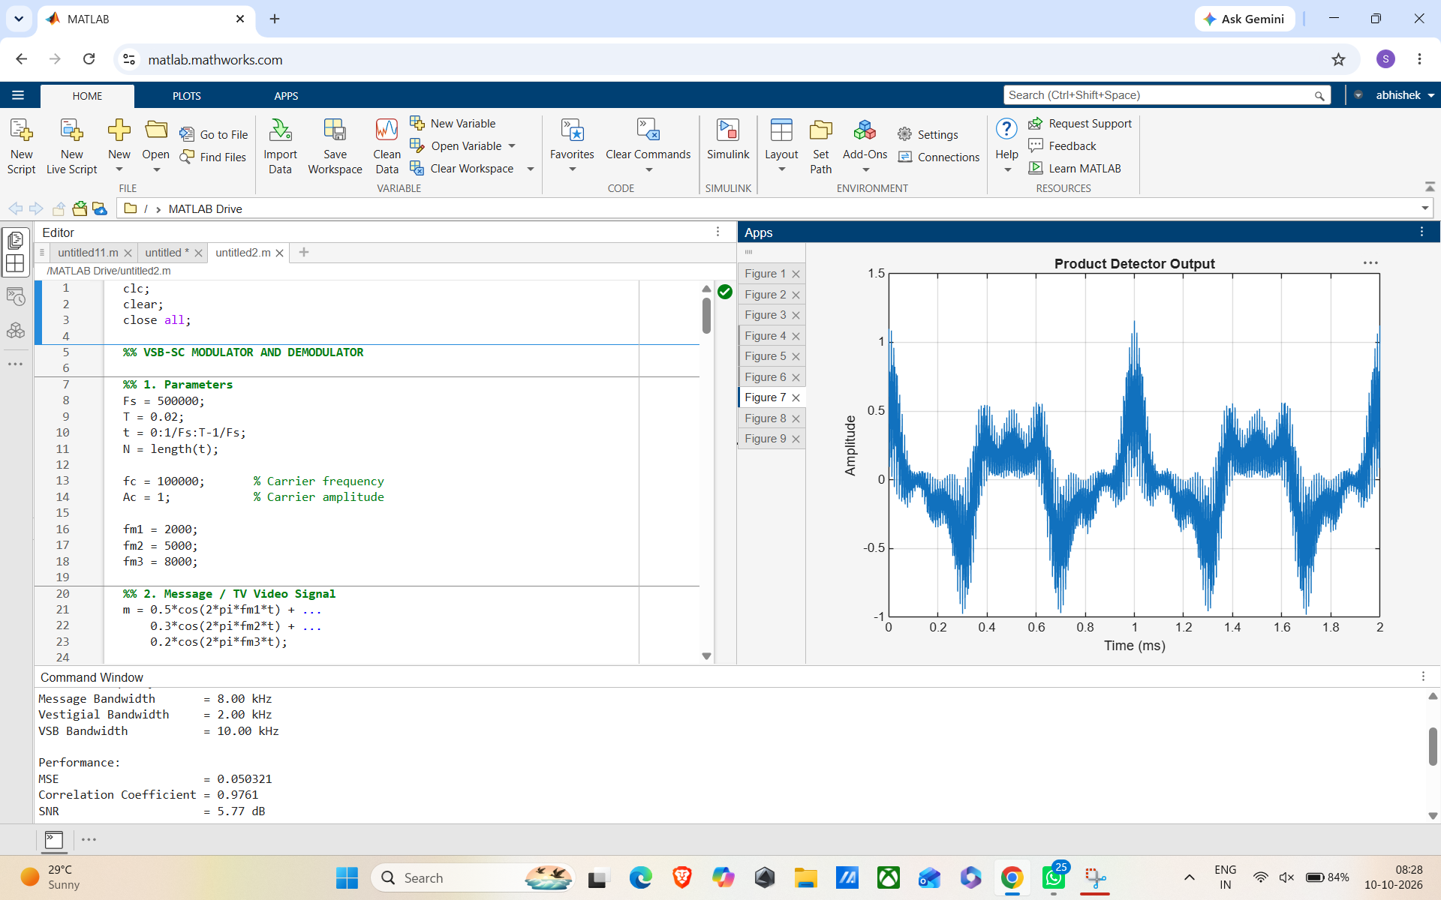
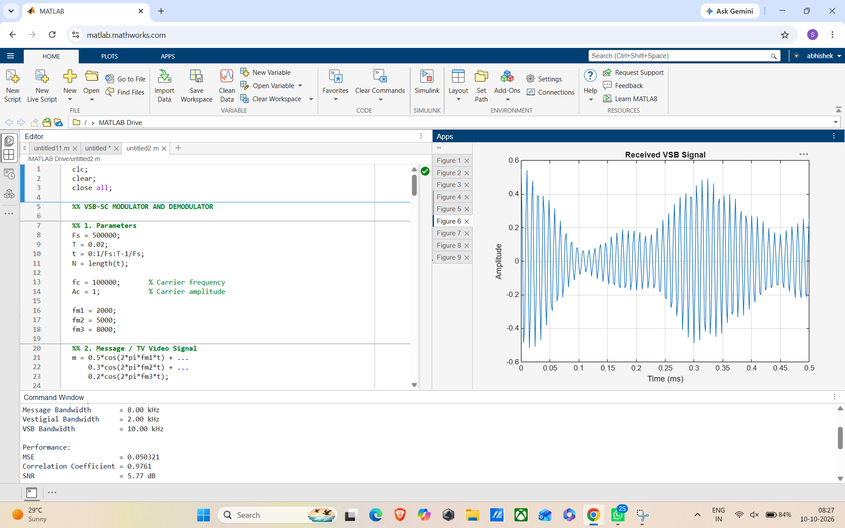
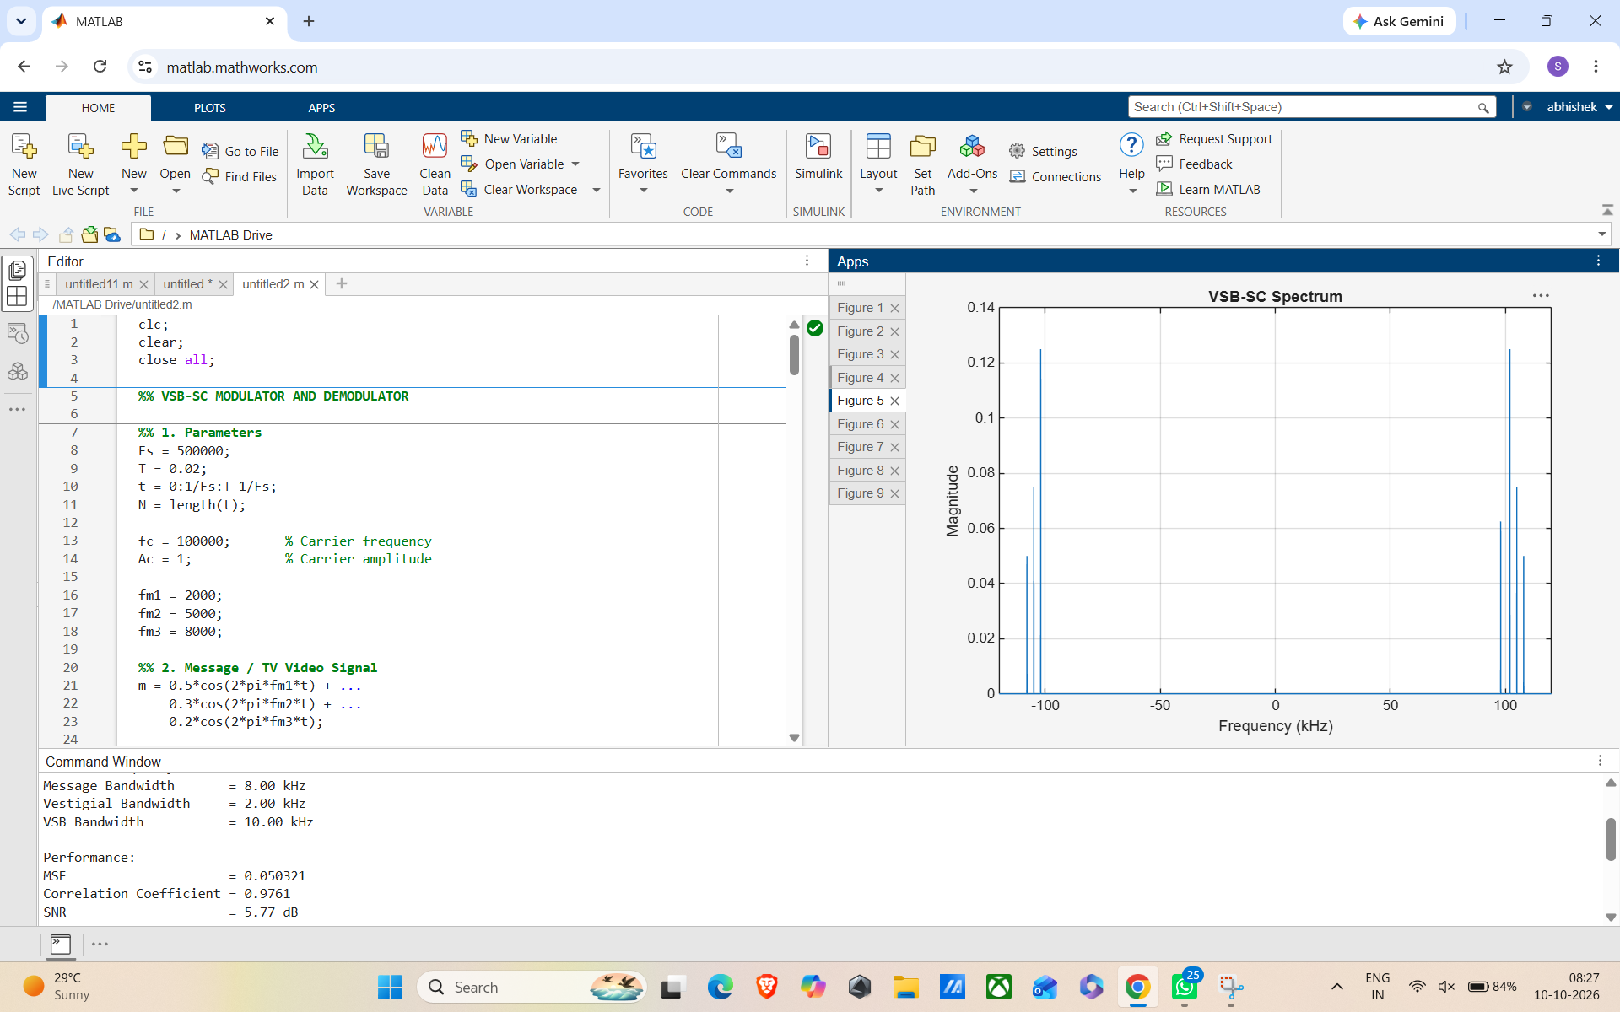
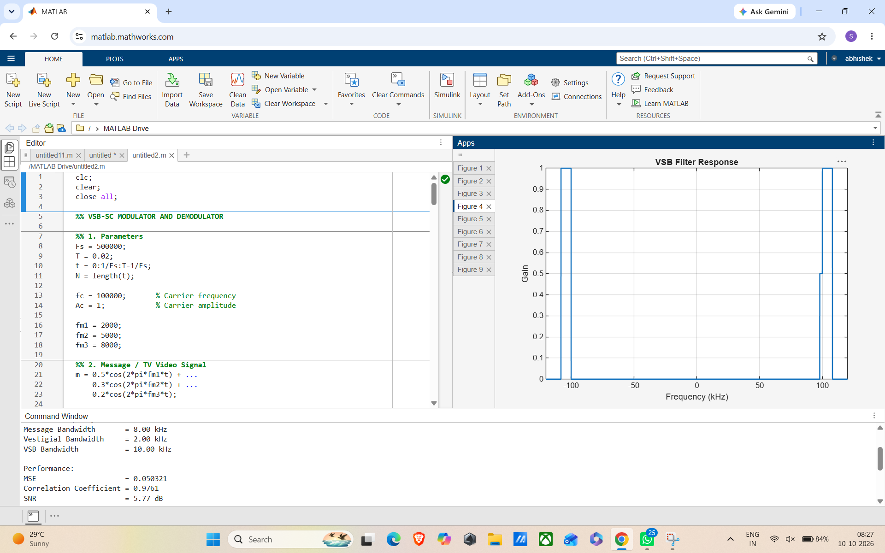
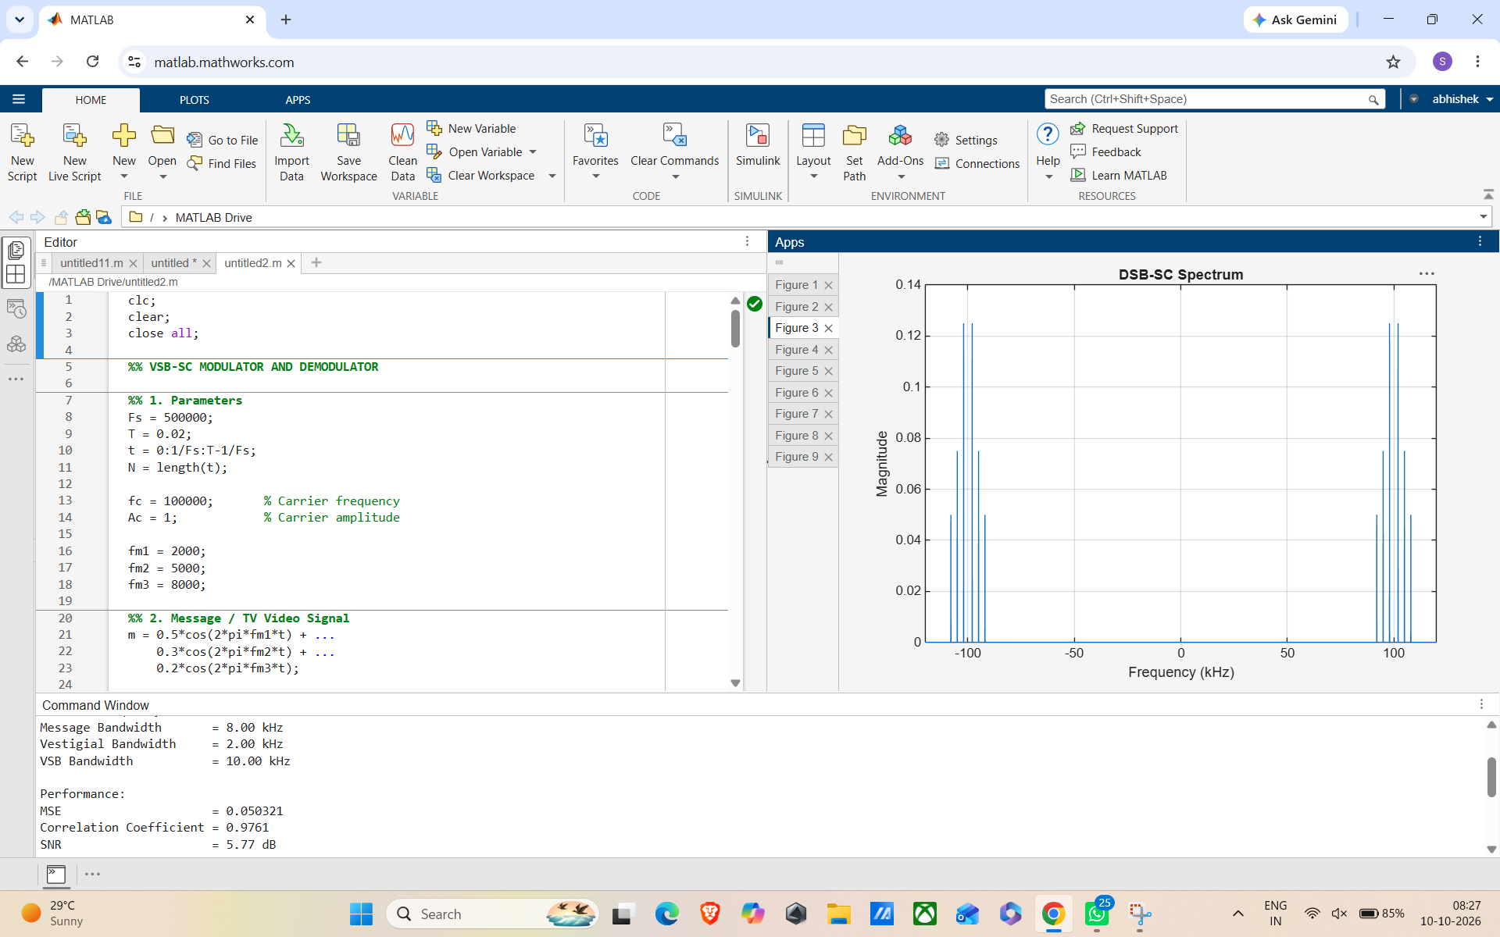
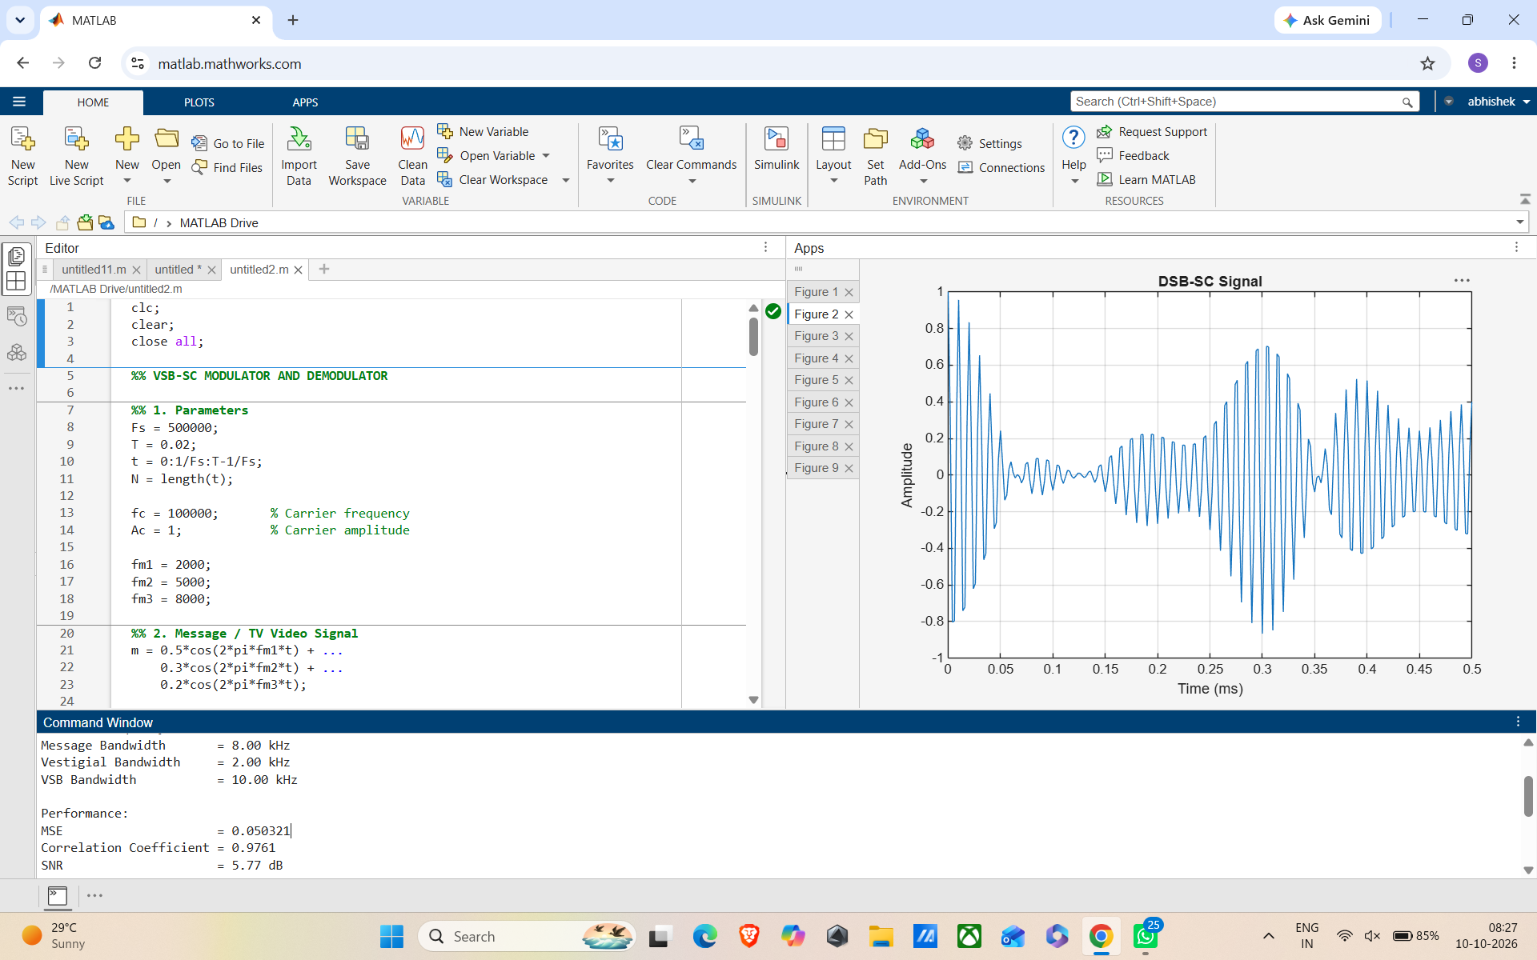
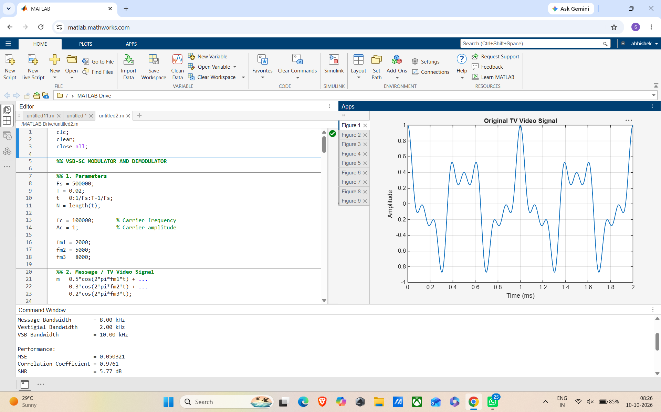

EXP-6
clc;
clear;
close all;
Am=1;
Ac=1;
fm=5;
fc=50;
beta=5;
kp=5;
fs=1000;
t=0:1/fs:1;
m = Am*cos(2*pi*fm*t); % Message signal

c = Ac*cos(2*pi*fc*t); % Carrier signal
fm_sig = Ac*cos(2*pi*fc*t + beta*sin(2*pi*fm*t)); % FM
pm_sig = Ac*cos(2*pi*fc*t + kp*m); % PM
Df = beta*fm; % Frequency deviation
fprintf('Frequency Deviation = %d Hz\n',Df);
fprintf('FM Modulation Index = %d\n',beta);
subplot(4,1,1), plot(t,m), title('Message Signal')
subplot(4,1,2), plot(t,c), title('Carrier Signal')
subplot(4,1,3), plot(t,fm_sig), title('FM Signal')
subplot(4,1,4), plot(t,pm_sig), title('PM Signal')

